ITRW 313 GitHub Documentation

Teamwork No: 11

|  |  |
| --- | --- |
| Team Members | Student Numbers |
| X.N. Sibiya | 28360583 |
| T. Sibutha | 26906880 |
| V. Sicwebu | 25370146 |
| C. Sithole | 28051467 |
| J. Sittig | 27483533 |
| S. Sivakumar | 26698218 |
| M.M. Skosana | 28182197 |
| R. Small | 27027228 |
| N. Smith | 27961192 |
| R. Snyman | 24227463 |

Table of Contents

Problem Statement 3

Diagrams 3

Planning document 3

End-user documentation 3

Problem Statement

//Xolile and Thato

Diagrams

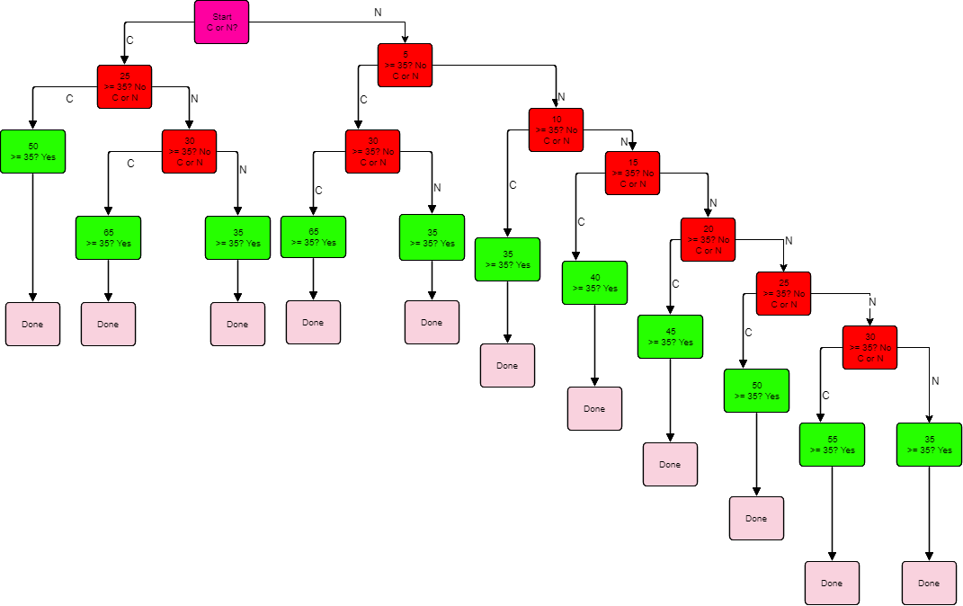

By: Chicko Sithole //Vusi, Thabiso Sithole and M.M. Skosana

Planning document

Our planning for this assignment consists of, one meeting, communication on a WhatsApp group and on the Efundi forum.

Our initial meeting was to establish who was in our ten person group. Everyone’s information was added and a WhatsApp group was created by Anjana Sivakumar. All initial communication was sent on this group.

We decided that Ruan Small would create the repository on GitHub and start the initial Finite State Machine clips code.

After the initial clips code was uploaded on the GitHub repository, it was decided to let all students add their GitHub usernames to the Efundi forum. After a few weeks of inactivity, working commenced again with adding the users to GitHub, only 6 out of the 10 members gave their usernames and was added to the GitHub.

New updates regarding the Vending Machine was given by the lecturer on the 17th April 2018. These updates were coded into the program during the week of the 10th April towards the 15th April 2018.

All documentation was to be finalized on the 15th of April 2018, so that it could be added to GitHub.

By: Jaco Sittig

End-user documentation

//Anjana, Ruan Small and Nathaniel

**Code to be submitted by members** (Please remove your part after you have submitted your code)

**XN Sibiya**

((deftemplate current-value

(slot value))

(deftemplate required-value

(slot value))

**Anjana Sivakumar**

(deffunction ask-question (?question $?allowed-values)

(print ?question)

(bind ?response (read))

(if (or (eq ?response R5) (eq ?response 5))

then (bind ?answer 5))

(if (or (eq ?response R2) (eq ?response 2))

then (bind ?answer 2))

**Ruan Snyman**

(if (or (eq ?response R1) (eq ?response 1))

then (bind ?answer 1))

(if (or (eq ?response c50) (eq ?response 50))

then (bind ?answer 0.50))

(if (or (eq ?response c20) (eq ?response 20))

then (bind ?answer 0.20))

**Nathaniel Smith**

(if (or (eq ?response c10) (eq ?response 10))

then (bind ?answer 0.10))

(while (not (member$ ?response ?allowed-values)) do

(println crlf "'" ?answer "' is not allowed. Please try again:" crlf)

(print ?question)

(bind ?answer (read)))

?answer)

**Thato Sibutha**

(deffacts vending

(current-value (value 0))

(required-value (value 0)))

;;;####################

;;; STARTUP

;;;####################

(defrule title ""

(declare (salience 10))

=>

(println crlf "Soft Drink Vending Machine" crlf))

**Chicko Sithole**

(defrule ask-for-coin

?f1 <- (current-value (value ?x))

(required-value (value ?y))

(test (< ?x ?y))

=>

(bind ?sum (+ ?x (ask-question "Enter amount (R5, R2, R1, c50, c20 OR c10) :" R5 R2 R1 5 2 1 c50 c20 c10 50 20 10)) )

(modify ?f1 (value ?sum))

(print crlf "=============================================================" crlf)

(format t "The amount required is : R%5.2f%s%n" ?y "c ")

(format t "The current amount is : R%5.2f%s%n" ?sum "c ")

(println "=============================================================" crlf)

)

**MM Skosana**

(defrule checkA-money_counter

(current-value (value ?x))

(required-value (value ?y))

(test (eq ?x ?y ) )

=>

(println crlf "You have just enough money to buy a soft drink!!" crlf)

)

**V V Themba**

(defrule checkB-money_counter

(current-value (value ?x))

(required-value (value ?y))

(test (> ?x ?y ) )

=>

(bind ?change (- ?x ?y))

(format t "You have enough money to buy a soft drink, with a change of: R%5.2f%s%n" ?change " c")

)